- This week has seen substantial volatility in global financial markets, but we think the implications for the UK economy are limited. The UK sell-off has been relatively modest. We also think there's a good chance that equity prices will recover because fears of a US recession are overblown.
- The Office for National Statistics presented some early results from the 2024 Blue Book revisions process. The GDP data for 2020-2021 is little changed, but the rebound in 2022 now looks slightly stronger. The revisions are unlikely to have a material impact on our macroeconomic forecasts, but some of the sectoral data looks very odd and could still be heavily revised in future.
It's been a turbulent week in financial markets, with traders worrying the US economy is slipping towards recession. The sell-off began last Friday in response to a disappointing US jobs report, with the rise in the unemployment rate breaching the Sahm rule, a closely watched recession indicator. Equity prices fell further on Monday, but have since recovered some of the lost ground, particularly after Thursday's stronger data on jobless claims. On Thursday, the UK's FTSE All Share closed just over 2% below its level of a week earlier.
We don’t expect recent market volatility to have a material impact on the UK economic outlook. And in any case, we think fears of a US recession are wide of the mark, so equity prices should recover. Higher US unemployment has been driven by increases in the workforce, rather than firms laying off workers, suggesting that the rise in unemployment is less worrying than the headline numbers imply. Other US data is also consistent with a more orderly and benign growth slowdown. Indeed, our US recession monitor shows the odds of a recession are lower than they were a year ago.
The little data that's been published this week suggests that UK activity is also continuing to run at a decent pace. The S&P Global survey reported an increase in the services PMI to 52.5 in July from 52.1 in June, underpinned by stronger demand. Meanwhile, the construction PMI reached 55.3, its highest level since May 2022. GDP grew at an above-trend pace of 0.6%-0.7% per quarter in H1 2024, and the early data for Q3 suggests that the economy has been able to maintain much of its momentum (Chart 1).
Chart 1: The economy appears to have maintained decent momentum at the start of Q3
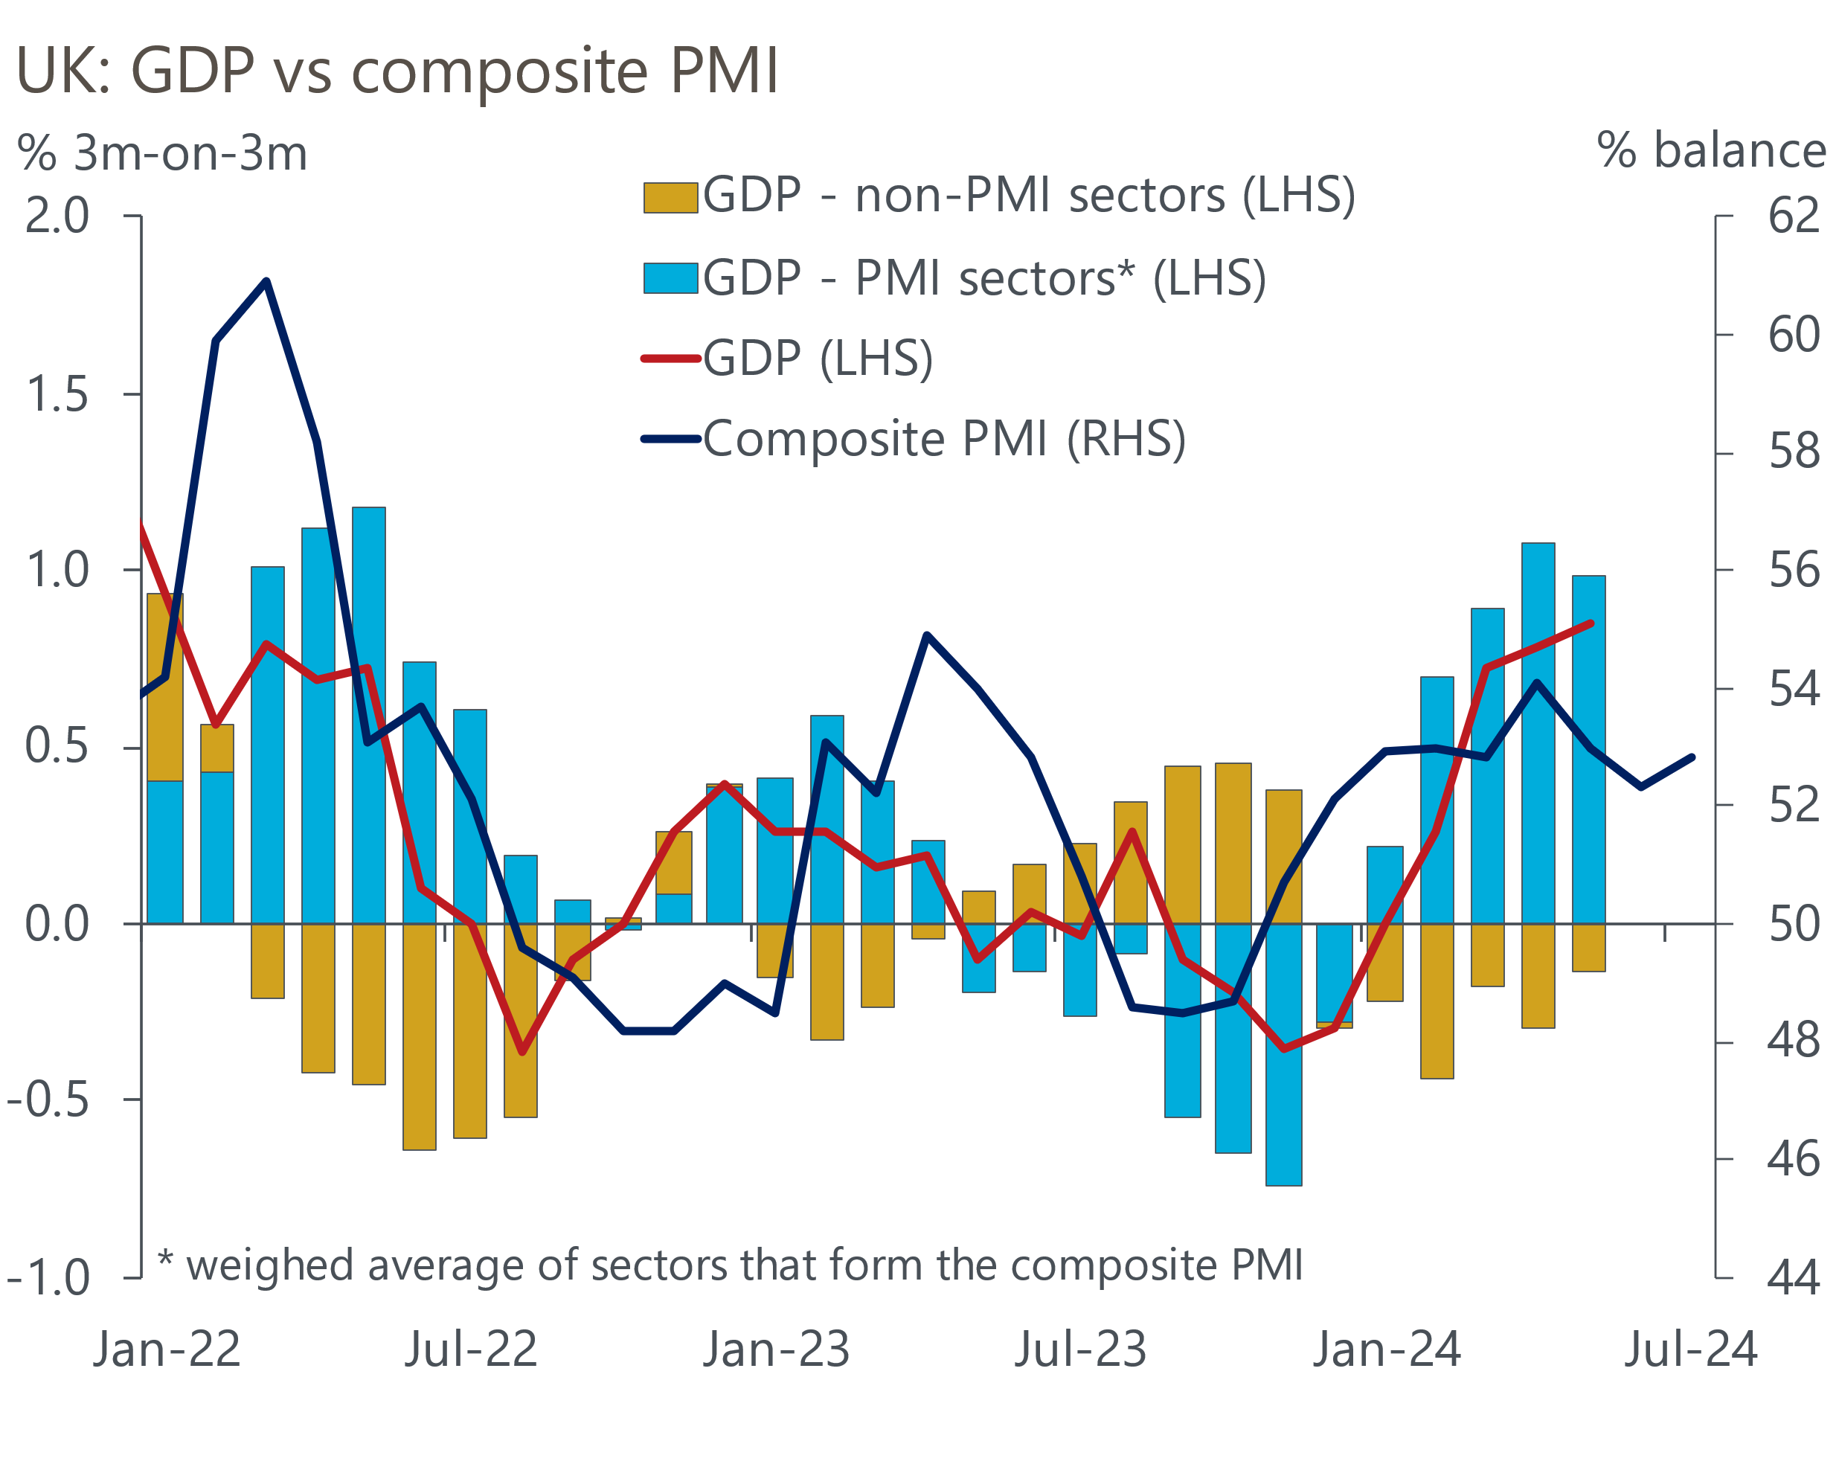
Sources: Oxford Economics, ONS, S&P Global

At the end of September, the Office for National Statistics will publish its annual rewrite of UK economic history, with the 2024 Blue Book introducing methodological improvements and integrating better, but less timely data. This week, the ONS published an analysis of how the data will change from 1997 to 2022. The data for 2022 has been put through the Supply and Use Table s (SUTs) framework for the first time, while the estimates for 2020 and 2021 have been improved with updated data.
The revisions to 2020 and 2021 are astoundingly small given the unprecedented challenges faced by the ONS in those years and the scale of earlier revisions. GDP is now estimated to have fallen by 10.3% in 2020 and rebounded by 8.6% in 2021 (previously 10.4% and 8.7%).
The revisions for 2022 are larger, with calendar year growth upgraded to 4.8% from 4.3%. Whereas previously, the data suggested that the economy began to flatline as soon as the boost from the end of social distancing restrictions had faded, the new quarterly profile shows the economy maintaining stronger momentum through 2022. The upgrade to 2022 GDP growth is almost entirely due to stronger consumer spending. As a result, the new data suggests the household saving ratio fell much further than previously thought during 2022, dropping below the 2010-2019 average. This changes the narrative around 'excess saving' a little during this period, though we will have to wait to find out whether there will also be revisions to more recent periods, when the savings ratio rebounded again.
The story of how the UK fared during the pandemic compared with its peers is little changed. Partly due to methodological differences, the new data still shows the UK having the largest fall in GDP in the G7 in Q2 2020 and remaining at the bottom of the G7 league table until mid-2021. Though the subsequent recovery now looks slightly stronger, the UK remains in the middle of the G7 range, well behind the US.
Last year's vintage had left us with a series of peculiarities at a sectoral level. But in many respects, the new version looks odder still. Health output is now estimated to have been nearly 10% below its 2019 level in December 2022 (previously 1% above), with a similar shortfall for retail output (previously 7% below). Meanwhile, manufacturing output is still estimated to have risen by 2% in 2020, despite many factories being shut for several months during the first lockdown, and output is now seen to have slumped by more than 7% in 2022, at a time when the wider economy was recovering strongly (Chart 2). We would be surprised if there aren't more large revisions in future Blue Books.
Chart 2: The new sectoral output data looks highly questionable
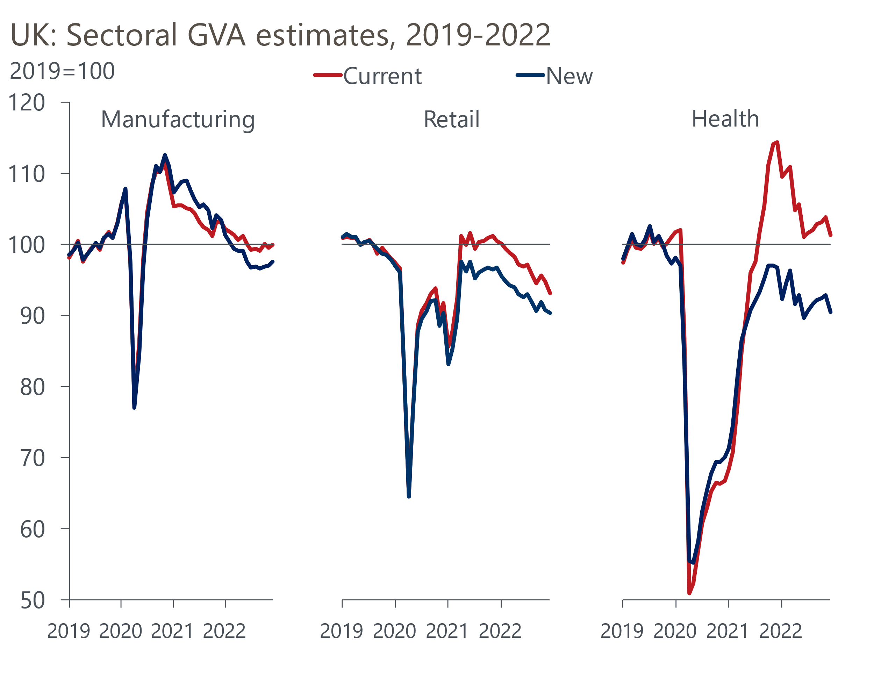
Source: ONS
Data for 2023 and H1 2024 that's consistent with the Blue Book series won't be available until the end of September, with next week's GDP release for Q2 2024 still using the old version of the data. The full dataset will be included in our October global forecast release and will be used in the Office for Budget Responsibility's forecast that accompanies the Budget on October 30. Based on experience, we would expect the OBR to assume that growth in potential output has also been slightly stronger than previously thought, but that there are no implications for its forecast, which is already on the strong side of consensus.

The week ahead
A busy week begins with Tuesday's labour market release, which will give us Q2 data points for most of the key variables. Pay growth started to cool in the three months to May, aided by strong base effects, and the timelier HMRC series suggests this trend will continue in June's data. The drop in the total pay measure is likely to be particularly large, given that last June saw workers in the NHS and civil service receive one-off bonus payments. We expect regular pay growth to drop to 5.4% in the three months to June, with total pay falling to 4.5%.
On the quantities side, the Office for National Statistics has announced a six-month delay to the implementation of the Transformed Labour Force Survey, so next week's release will continue to suffer from the volatility caused by low response rates. Based on the available monthly data, we expect the unemployment rate to tick up to 4.5% in Q2.
June's upside surprise for inflation was largely due to exceptionally high increases in prices at two hotels, possibly connected to Taylor Swift's tour. We expect this to unwind in July's data. However, the drag from the energy category will fall in July, with this year's 7% fall in the energy price cap being less than half of the drop seen last summer. As a result, we estimate that CPI inflation rose to 2.2% in July, from 2% in June.
GDP rose by 0.4% m/m in May, but we expect there to have been some payback in June. Retail sales fell by more than 1% m/m in June, suggesting the consumer sector endured a challenging end to Q2. And four days of strike action by junior doctors at the end of June is likely to have dragged on output in the health sector via the cancellation of operations and appointments. Overall, we estimate that GDP fell by 0.2% m/m in June which – absent revisions – would leave GDP up by 0.5% or 0.6% in Q2.
Retail sales has always been a noisy series, but the month-to-month volatility over the past year has been exceptional. June's sharp fall in sales reflected drops across all the non-fuel sectors. But each of the previous slumps has been followed by a strong rebound and, with the underlying drivers of consumer demand remaining supportive, we expect this to be the case again in July. We forecast that sales rose by 0.7% m/m in July.

Table 1: Week ahead calendar
Date | Events | Period | Measure | Unit | Previous | Forecast
Aug 13 | LFS unemployment | Apr-Jun | Rate | % | 4.4 | 4.5
Aug 13 | Average earnings (total pay) | Jun | 3m, y/y | % | 5.7 | 4.5
Aug 13 | Average earnings (regular pay) | Jun | 3m, y/y | % | 5.7 | 5.4
Aug 14 | CPI inflation | Jul | m/m | % | 0.1 | -0.2
Aug 14 | CPI inflation | Jul | y/y | % | 2.0 | 2.2
Aug 14 | RPI inflation | Jul | m/m | % | 0.2 | 0.1
Aug 14 | RPI inflation | Jul | y/y | % | 2.9 | 3.6
Aug 14 | Producer input prices | Jul | m/m | % | -0.8 | 0.2
Aug 14 | Producer input prices | Jul | y/y | % | -0.3 | 0.3
Aug 14 | Producer output prices | Jul | m/m | % | -0.3 | 0.1
Aug 14 | Producer output prices | Jul | y/y | % | 1.4 | 1.3
Aug 14 | Land Registry house prices | Jun | y/y | % | 2.2 | 1.8
Aug 15 | GDP | Jun | m/m | % | 0.4 | -0.2
Aug 15 | GDP | Jun | 3m/3m | % | 0.9 | 0.6
Aug 15 | Index of services | Jun | m/m | % | 0.3 | -0.3
Aug 15 | Index of services | Jun | 3m/3m | % | 1.1 | 0.8
Aug 15 | Manufacturing output | Jun | m/m | % | 0.4 | 0.0
Aug 15 | Manufacturing output | Jun | y/y | % | 0.6 | -2.5
Aug 15 | Industrial production | Jun | m/m | % | 0.2 | 0.0
Aug 15 | Industrial production | Jun | y/y | % | 0.4 | -2.2
Aug 15 | Construction output | Jun | m/m | % | 1.9 | -0.2
Aug 15 | Construction output | Jun | y/y | % | 0.8 | -2.3
Aug 15 | UK trade | Jun | Trade balance | £bn | -4.9 | -2.0
Aug 15 | UK trade | Jun | Visible balance | £bn | -17.9 | -15.2
Aug 16 | Retail sales inc fuel | Jul | m/m | % | -1.2 | 0.7
Aug 16 | Retail sales inc fuel | Jul | y/y | % | -0.2 | 1.4
Source: Oxford Economics

Key forecasts
Table 2: UK forecast overview
(Annual percentage changes unless specified)
 | 2022 | 2023 | 2024 | 2025 | 2026 | 2027
GDP | 4.3 | 0.1 | 1.1 | 1.8 | 1.8 | 1.7
Private consumption | 4.8 | 0.2 | 0.8 | 2.3 | 2.1 | 1.6
Fixed investment | 8.0 | 2.2 | -0.1 | 1.2 | 2.5 | 2.1
Government consumption | 2.3 | 0.5 | 2.6 | 2.9 | 1.6 | 1.5
Exports of goods and services | 9.0 | -0.5 | -2.3 | 2.4 | 2.2 | 1.7
Imports of goods and services | 14.6 | -1.5 | -0.5 | 3.5 | 2.8 | 1.8
Industrial Production | -3.5 | -0.4 | -0.3 | 0.8 | 1.5 | 1.2
Consumer prices | 9.1 | 7.3 | 2.6 | 2.5 | 2.3 | 2.2
Unemployment rate (%) | 3.9 | 4.0 | 4.4 | 4.3 | 4.0 | 3.9
Current a/c balance (% of GDP) | -3.1 | -3.3 | -3.4 | -3.2 | -3.3 | -3.2
Government balance (% of GDP) | 4.4 | 5.0 | 4.1 | 3.1 | 2.4 | 1.6
Cen. bank policy rate (%, EOP) | 3.50 | 5.25 | 4.75 | 3.75 | 2.75 | 2.00
10yr govt. bond yield (%, EOP) | 3.67 | 3.54 | 3.91 | 3.66 | 3.22 | 2.85
Exchange rate (US$ per £, EOP) | 1.20 | 1.27 | 1.28 | 1.28 | 1.30 | 1.32
Exchange rate (euro per £, EOP) | 1.13 | 1.15 | 1.18 | 1.17 | 1.17 | 1.16
Source: Oxford Economics
Table 3: Quarterly forecasts for the UK
 | 2024 |  |  |  | 2025
 | Q1 | Q2 | Q3 | Q4 | Q1 | Q2 | Q3 | Q4
GDP (% year) | 0.3 | 0.8 | 1.2 | 2.0 | 1.7 | 1.7 | 1.9 | 1.9
CPI inflation (% year) | 3.5 | 2.1 | 2.1 | 2.5 | 2.5 | 2.3 | 2.6 | 2.4
Bank Rate (%, EOP) | 5.25 | 5.25 | 5.00 | 4.75 | 4.50 | 4.25 | 4.00 | 3.75
10yr gilt yield (%, EOP) | 3.95 | 4.17 | 3.95 | 3.91 | 3.86 | 3.80 | 3.74 | 3.66
US$ per £ (EOP) | 1.26 | 1.26 | 1.27 | 1.28 | 1.28 | 1.28 | 1.28 | 1.28
Euro per £ (EOP) | 1.17 | 1.18 | 1.18 | 1.18 | 1.18 | 1.18 | 1.17 | 1.17
Source: Oxford Economics

Latest Country Economic Forecast:
July 16, 2024

Recent publications

Data Insights
Services activity growth improves, as inflation continues to cool
Manufacturing PMI rose to a two-year high in July
Elevated mortgage rates continued to weigh on approvals in June
Flash PMIs suggest the economy got off to a solid start in Q3
Noisy retail data masks gradual underlying improvement

Research Briefings
Rate-cut cycle kicks off but it’s unlikely to be sequential
Reeves review lays the ground for October tax rises
MPC preview – Markets hold the key to timing of rate cut
Labour's fiscal inheritance and the Reeves Review
MPC prepares the ground for an August rate cut

Contacts

Oxford Economics' UK team
- Andrew Goodwin - Chief UK Economist - agoodwin@oxfordeconomics.com
- Edward Allenby - UK Economist - eallenby@oxfordeconomics.com

